Android App CI (Done)

1. Import the code from <https://github.com/niedev/RTranslator> --> clone it
2. Use classic editor and select the android default task.
3. Adjust the JDK version in Gradle build task to 11
4. Install JDK 11 installer from oracle site
5. Add the bin path of JDK in PATH variable of system environment variables
6. Run the command in cmd to create a keystore file
   1. Keytool -genkey -v -keystore my-release-key.keystore -keyalg RSA -keysize 2048 -validity 10000 -alias my-key-alias 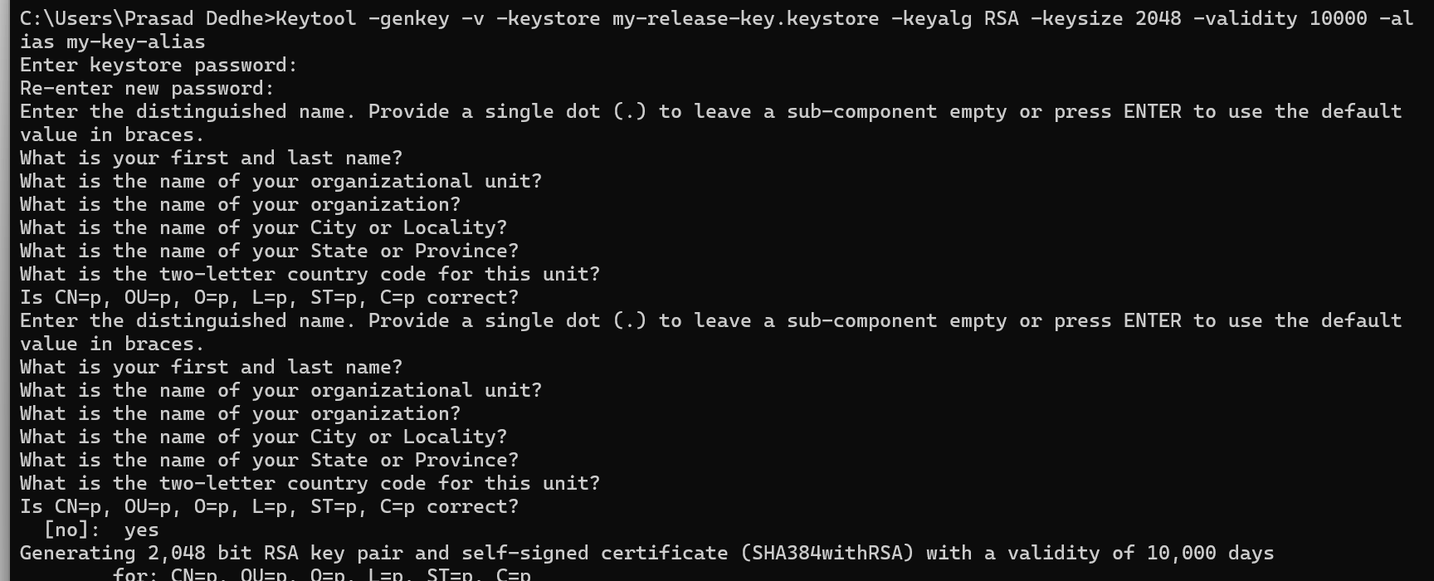
   2. keytool -list -v -keystore D:\a\_temp\my-release-key.keystore 🡪 to see the details and verify of the generated file (optional) 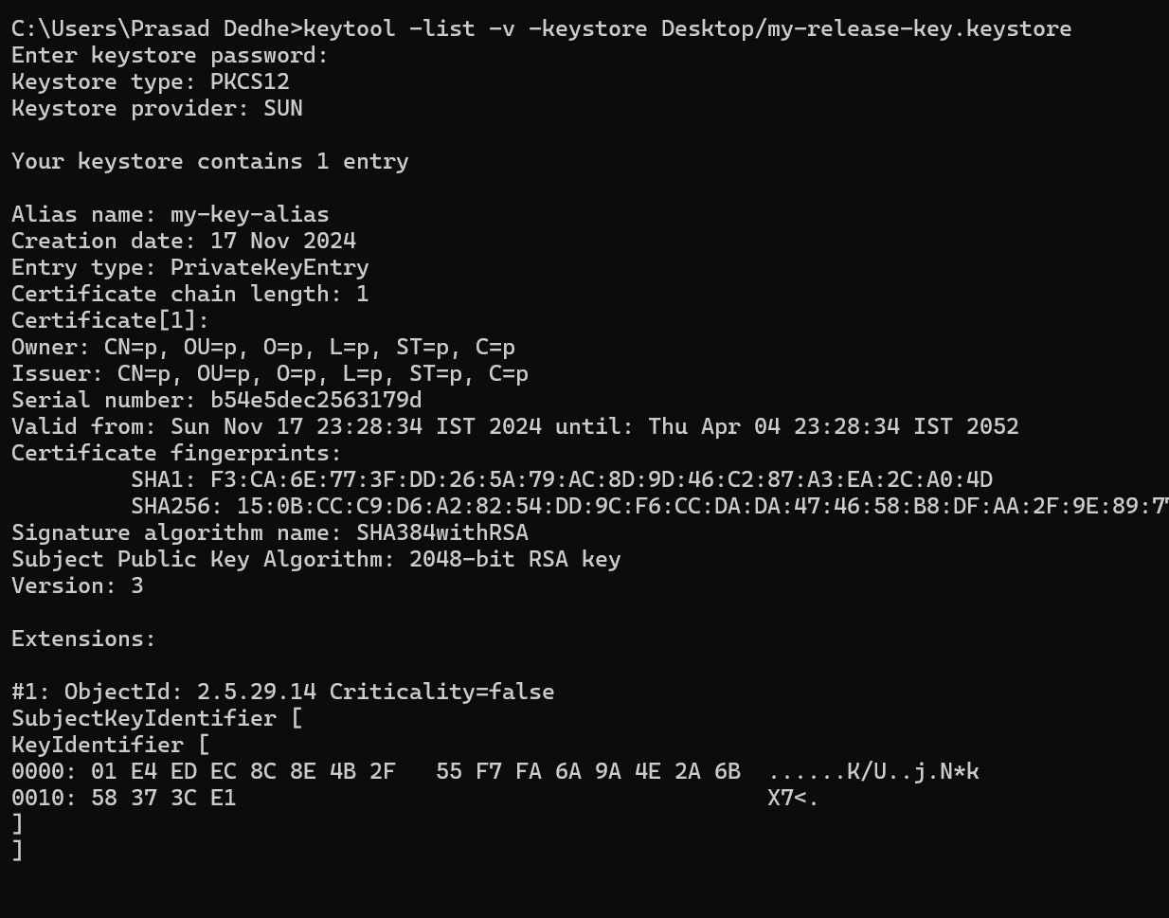
7. After that fill the information it asks you and in the sign task of Azure DevOps select the file generated by previous command 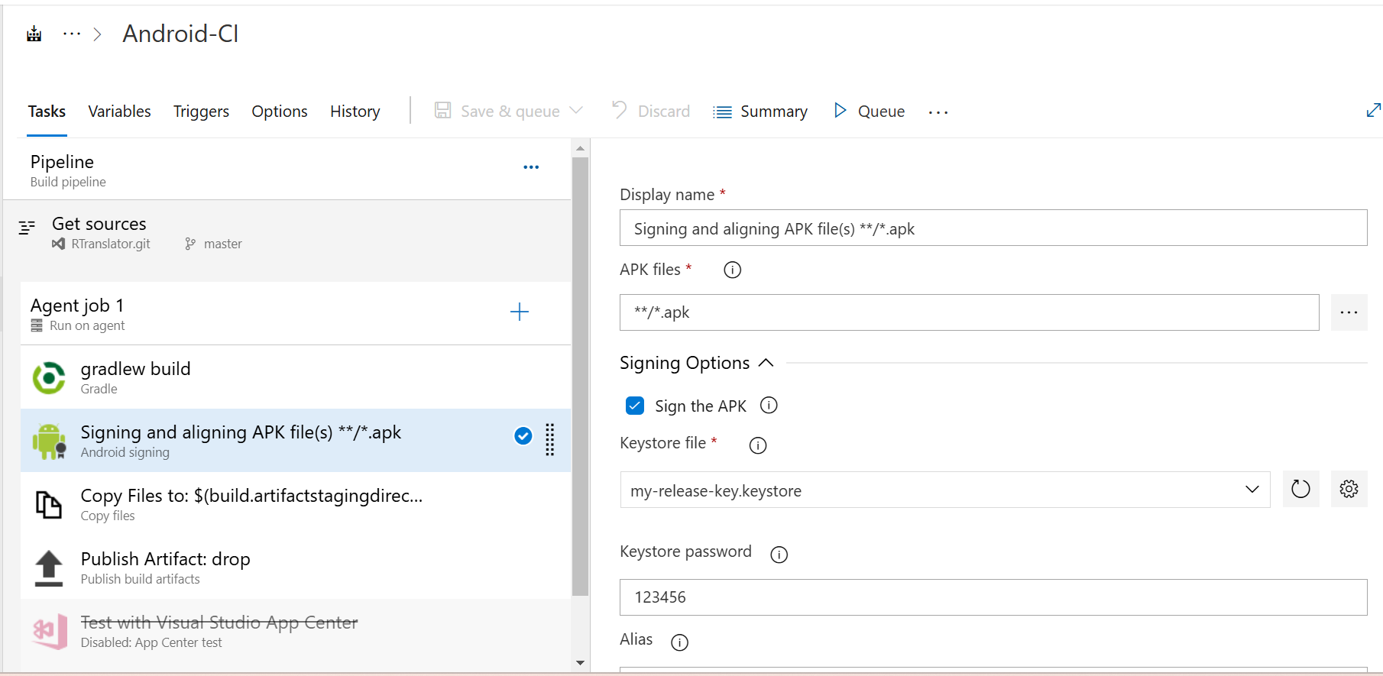
8. In this task, fill every option even though its optional, else the build will fail.

Android App CD (Theorized)

1. Google Play Store extension you have to add to your organization
2. Add Release to internal task to your pipeline
3. Create an account on Google Play Console (25$ fee is there with D-U-S-N 9digit number) 🡪 https://play.google.com/console/signup
4. After that you need to create a google cloud project (why? Because google play console doesn’t allow Azure DevOps to connect to it directly. So, you need to create google cloud project as a mediator between Azure DevOps & Google Play Console (link to create google cloud project 🡪 <https://console.cloud.google.com>)
5. Post that Enables Google Play Developer API in newly created project in Google Cloud Console.
6. After that create a service account in Google Cloud Console. (No need to assign any permission to this account)
7. Then in Google play console, give this service account role Release manager or admin.
8. The details of these service connection add to the task.
9. Select your APK $(Build.ArtifactStagingDirectory)/my-release.apk and fill other configurations. Post this create release and watch the app getting updated on Google Play Store.
10. 